Here are a few tips when using CityProtect.com:

Home Screen:
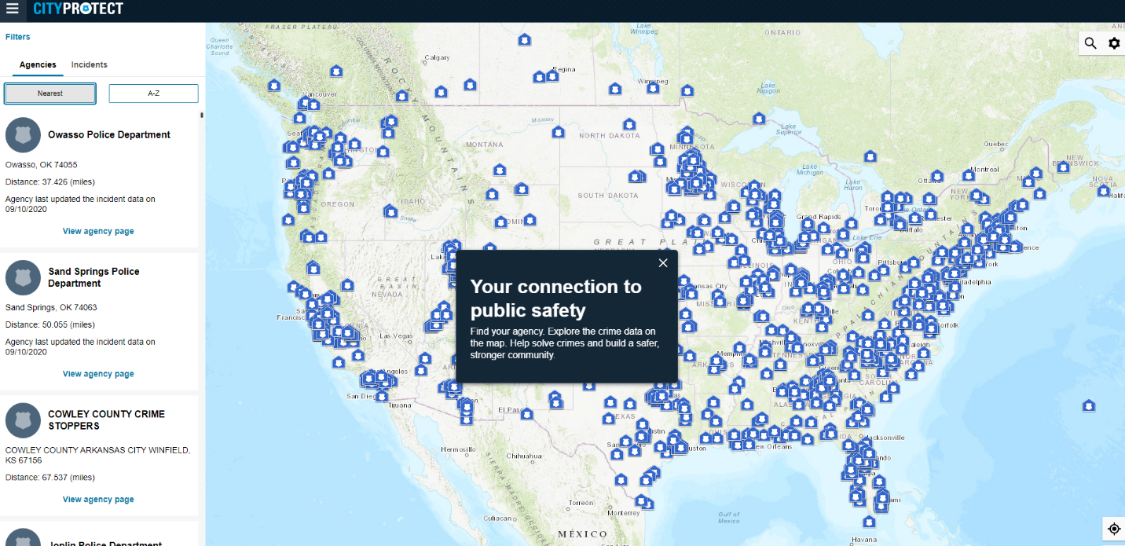
General crime map review:
Search Urbana, IL in the search bar on the top right of the map (you can also set Urbana as your home area). Zoom in using the plus sign on the bottom right of the map or your mouse.
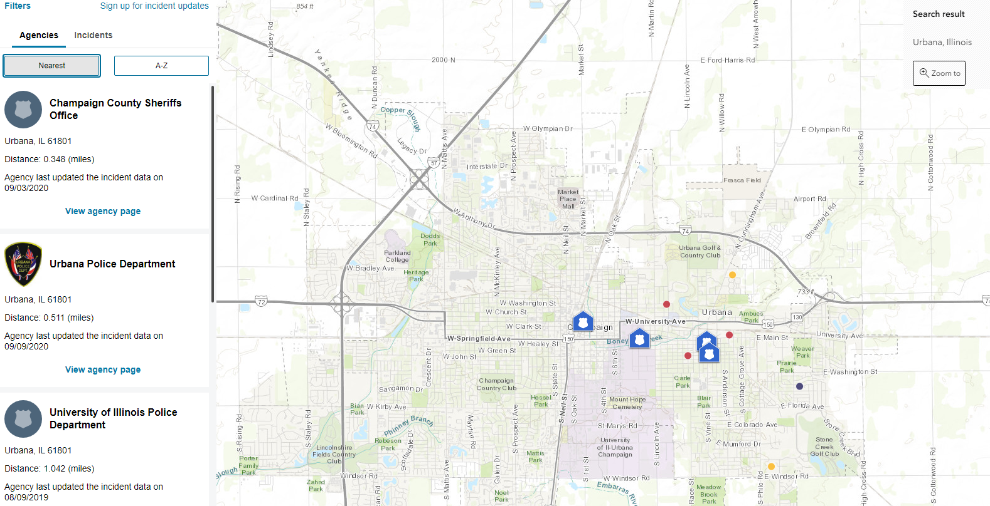

- Go to top left of the page and click on FILTERS. Click on the desired filters (range of dates, time frame, incident types) and then click SEE RESULTS at the bottom
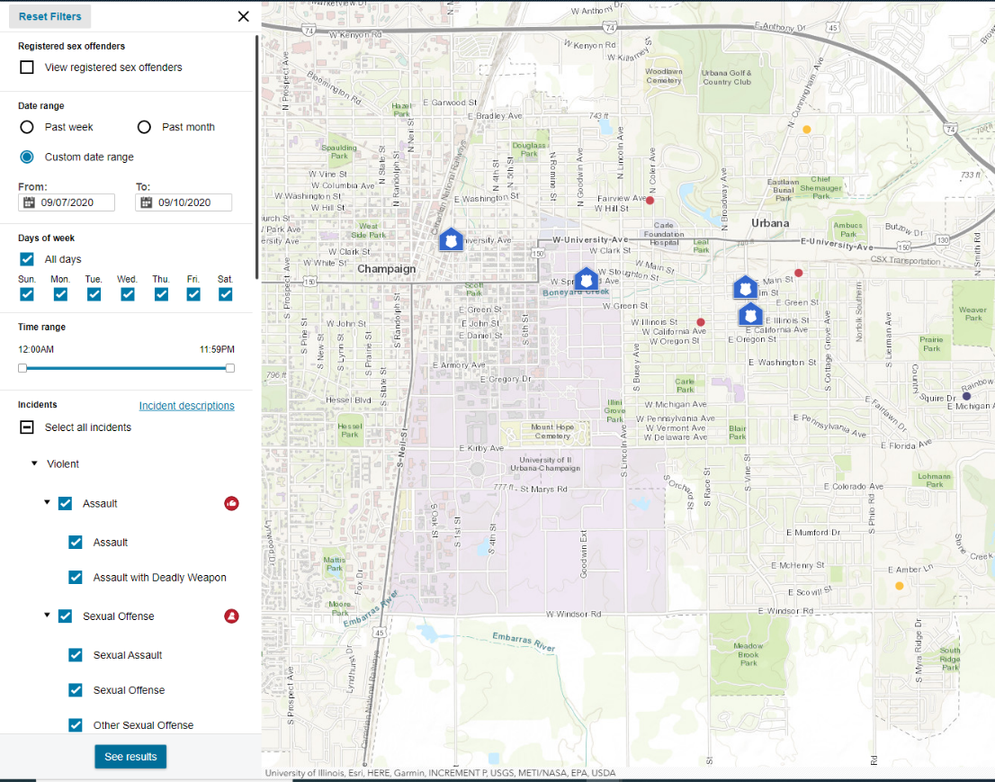
- Zoom in using the plus sign on the bottom right of the map or your mouse. Click on each incident, highlighted in red, yellow or blue to get a brief description and location of the incident.

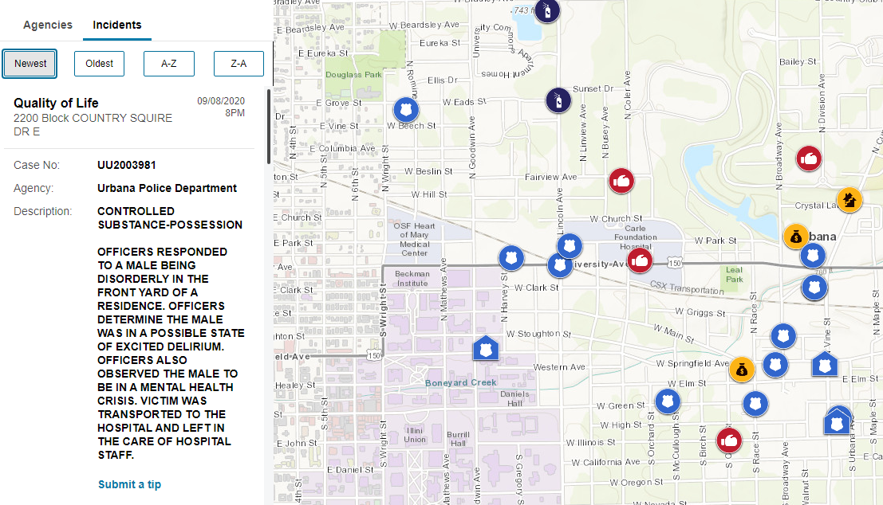
You can also get email updates when you select Sign up for incident updates next to the filter section.

Agency Home Page (Urbana PD):
To view the agency home page go to CityProtect.com and click on the three lines at the top left to the left of City Protect. 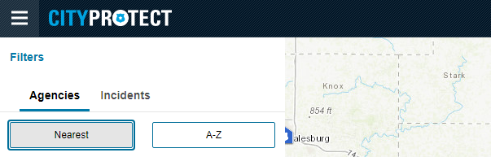
That will bring down a list of options Find an agency, Register Cameras, Explore crime map, View previously submitted reports, About CityProtect
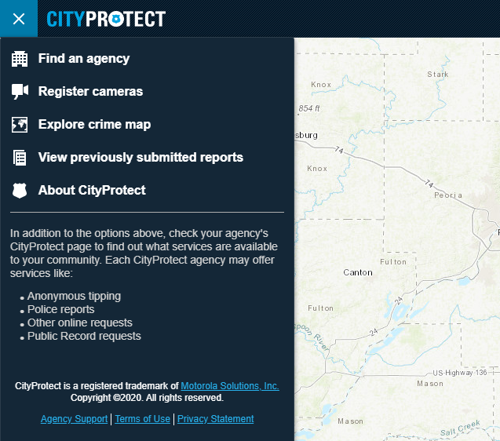
Click Find an agency and search for Urbana Police Department. Click on view agency page.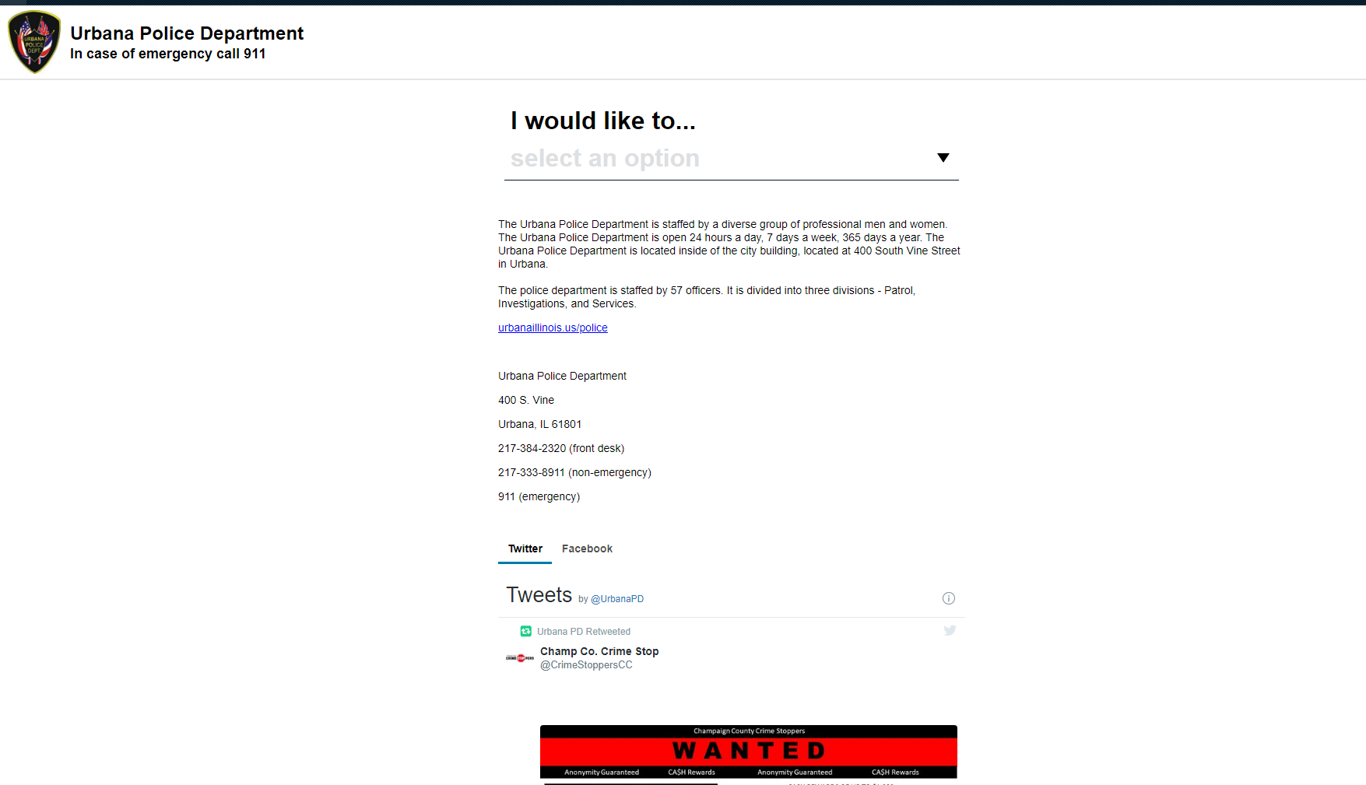

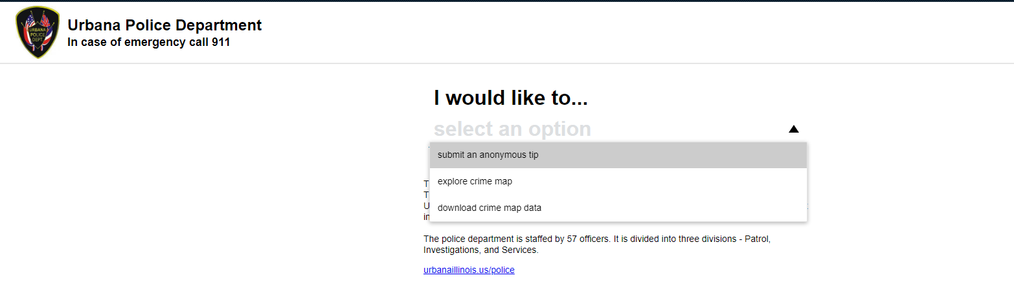
Select one of the drop down items for what you would like to do-submit tip, explore crime map, download crime map data

