Neighborhood Watch
“A partnership between the Urbana Police Department and the Urbana Community”

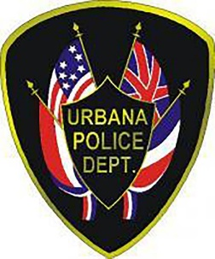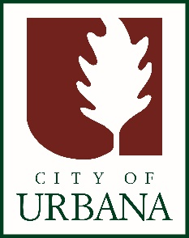

A Neighborhood Watch program is a group of people living in the same area who want to make their neighborhood safer by working together and in conjunction with local law enforcement to reduce crime and improve their quality of life

How to Get Started:
- Contact UPD to find out if a group already exists in your neighborhood
- If starting a new group-recruit neighbors and select a block captain
- Establish a means of communication for watch members (phone/social media/email)
- Plan an initial meeting and include UPD (an officer will be assigned as a liaison to your group)
- Stay in touch with watch members and schedule regular meetings or contact to keep group active

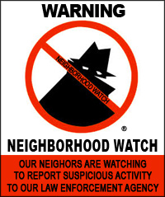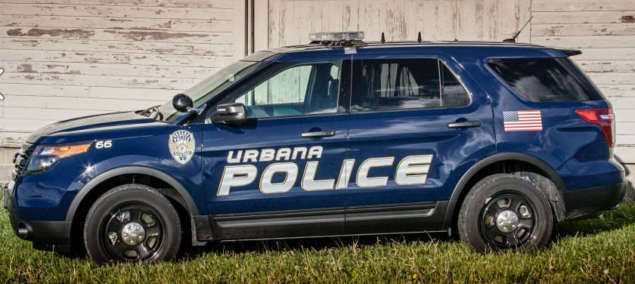

For more information and material on how to begin a Neighborhood Watch program, contact:

Sgt. Betsy Alfonso: alfonsel@urbanaillinois.us
Community Engagement Coordinator Lemond Peppers: slpeppers@urbanaillinois.us
https://urbanaillinois.us/neighborhood-watch
Urbana Police Department-217-384-2320

